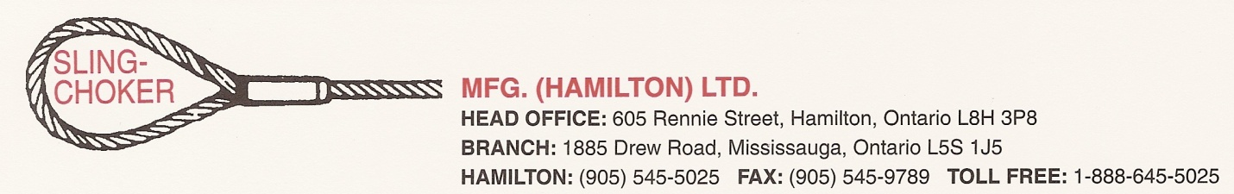

Credit Application
General Information

Legal Company Name: ______________________________________________________________________________________

Affiliate Company Name (if any): _____________________________________________________________________________

Physical Address: __________________________________________________________________________________________

Mailing Address: _____________________________________________City: ___________________________ Prov: ________

Postal Code : _____________ Tel: _________________________ Fax: ____________________ E-mail:____________________

Type of Industry : Steel Construction Communication Transportation Other : ____________

Accounts Payable Contact: _____________________________________________Tel (if different): _____________________

Company Owner(s) – Principals Business Information

Name _____________________________________________  Address____________________________________________  City _________________________________Prov__________  Postal Code_______________ E-Mail___________________  Tel______________________ Fax _____________________  Driver’s License No. _____________________________ | Type of Ownership __ Individual __Partnership __Corporation  Type of Business: ____________________________________  # of years in Business_____ Are PO’s required? __yes ___no  Assignment of accounts receivable ___yes ___no  To whom _________________________________________
Number of Employees______ Annual Sales $________________ Credit Requested $________________

Bank Information

Name of Bank____________________________________ Transit__________ Account Number_________________________

Address_________________________________________ Account Manager _________________________________________

Tel _______________________ Fax_____________________

Type of account: ___ Business or ___Personal

Trade References City Phone Fax
1.

2.

3.

4.

Application must be completed in its entirety to facilitate processing

- We / I make this application for a charge account and give Sling-Choker Mfg. (Hamilton) Ltd. authorization to obtain and report Business information and Personal credit information on the principals of this company including detailed bank reports through
the services of a credit bureau for the purpose of opening this account and monitoring it for this business relationship.
- We / I authorize the exchange of business and personal information on an ongoing basis with credit bureaus and other trade suppliers in order to protect and ensure the completeness of the information and to maintain the integrity of the credit granting system.
- We / I authorize the co-operation with local, provincial and national authorities in the investigation of unlawful or improper
activities in order to protect both parties from fraudulent transactions.
- We / I authorize the disclosure of business and personal information where necessary to protect your interests, and ours.

Applicants Name _________________________________________

Principal’s Signature__________________________________________ Date ___________________

Print name ______________________________________________ Title ______________________________

Terms – Net 30 Days – Interest 2% / month

For internal use:
Cr. Approved:___________________Limit:_________________Area:______________Type:______________

==================================================================================

Sling-Choker sends invoices daily via email. Please provide e-mail information for accounts payable.

Email: ________ Email Address:_________________________________ Attn:______________________________

Alternate:

Fax: _________ Fax Number:_____________________________ Attn:_____________________________________

Other: ______________________

Please indicate how you would like to settle your account:

Cheque: _________ Visa: ____________ Mastercard: _______ Amex:___________ Direct deposit:____________

If you choose Charge Card we will call you when the account is due to arrange settlement.

Direct Deposit Information: TD Canada Trust
43 Elm Street
Sudbury, ON
P3E 4R7
Contact: Mike Penwarden Tel: 705-669-4302

Transit: 37122

Canadian $ Acct: 0438-5210960

US $ Acct: 0438-7300530

Word/S/CreditApplication/AR001 Sling-Choker Credit Application June 7, 2013

